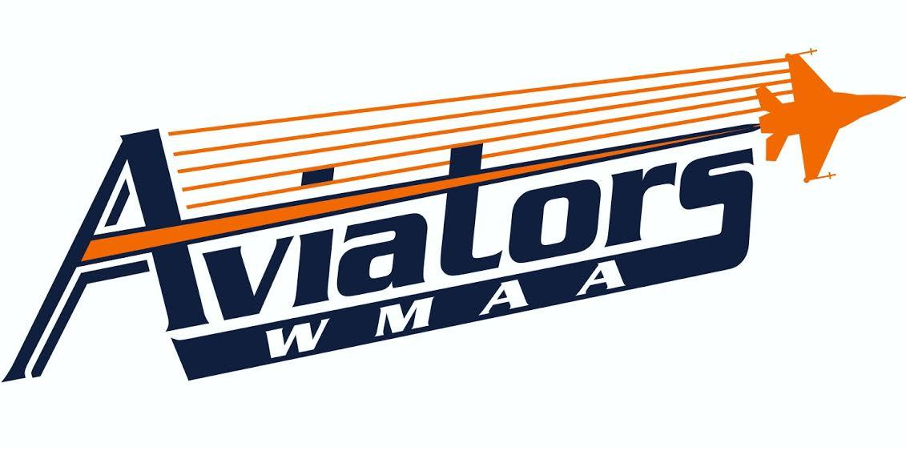
Student Athlete Behavior Contract
Athlete’s Name: ___________________________________
As student athletes, you are bound by a more strict moral and behavioral code than non student-athletes. As such, you will be responsible for conducting yourself in a manner above and beyond non student- athletes. If you choose to accept this responsibility, you must sign this contract, and in doing so, you agree to abide by the consequences set forth below:
Every member of the WMAA Cheer Club has a duty to represent herself/himself, the team and the school in the best manner possible. This applies to your behavior both in school and out of school. You are expected to avoid situations where you might be accused of wrong-doing. Being in the “wrong place at the wrong time” is not an excuse if you chose to be there in the first place.
In-school discipline problems resulting in Suspension may result in dismissal from the Cheerleading team. The following violations may also result in suspension or dismissal from the WMAA Cheer Club:
- Using illegal drugs, alcohol, or tobacco at any time.
- Allowing yourself to be in a situation, in school or away from school, where you are accused of/arrested for an illegal activity.
- Missing practice (unless excused by the Coach).
- Skipping class or school.
- Poor sportsmanship (No gossiping!)
- Harassment (verbal/physical/sexual/etc...) of another student or team member.
- Any act (either in school or away from school) which in the opinion of the coaching and/or school administration, reflects in a negative manner on the WMAA Athletic Program.
- Electronic communication (text, Facebook, Twitter, etc...) should be positive and should never negatively reflect on other teammates or coaching staff. If it’s negative don’t post it.
By signing below, you affirm that you have read this and fully understand the rules set forth by this contract. You are also stating that you understand that violations of the WMAA Athletic Program behavior policies could result in your being dismissed from the athletic program.
Player’s Signature: ____________________________________________ Date: _______________
Parent/Guardian Signature: _____________________________________ Date: _______________

